**Manage Veterinarians**

**‘List of Available Veterinarians’ Page** – This page shows you a detailed list of available veterinarians. Here, you will see the vet name and user name. You also have the option to edit or delete product information, see details and enter new details.

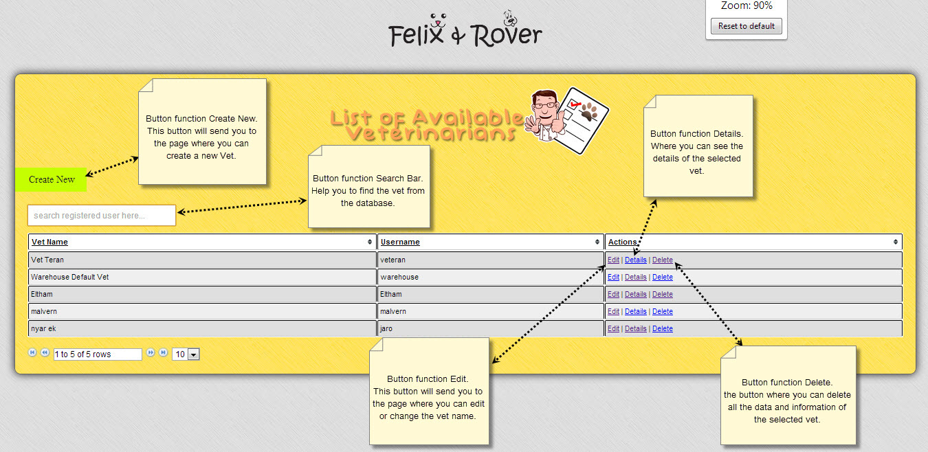

**‘Create New Veterinarians’ Page** – This page is where you enter type of your new veterinarians and also the details of the selected veterinarians.

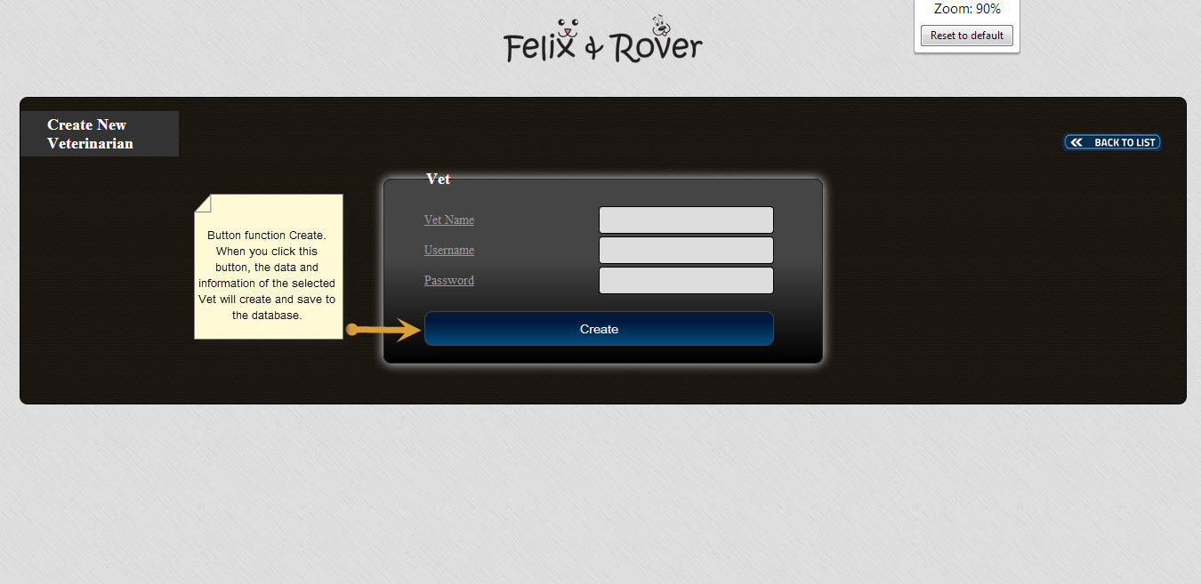

**‘Delete Selected Veterinarians ‘Page -** This page is where you go to if you wish to delete selected veterinarians.

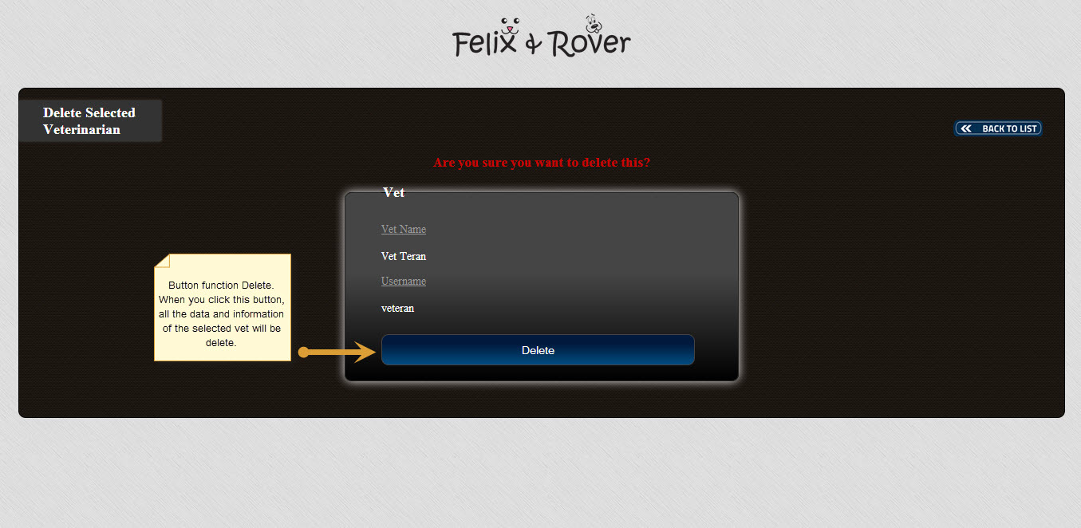

**‘Details of Veterinarians’ Page** – This page allow you to edit details of your product, such as its vet name and user name.

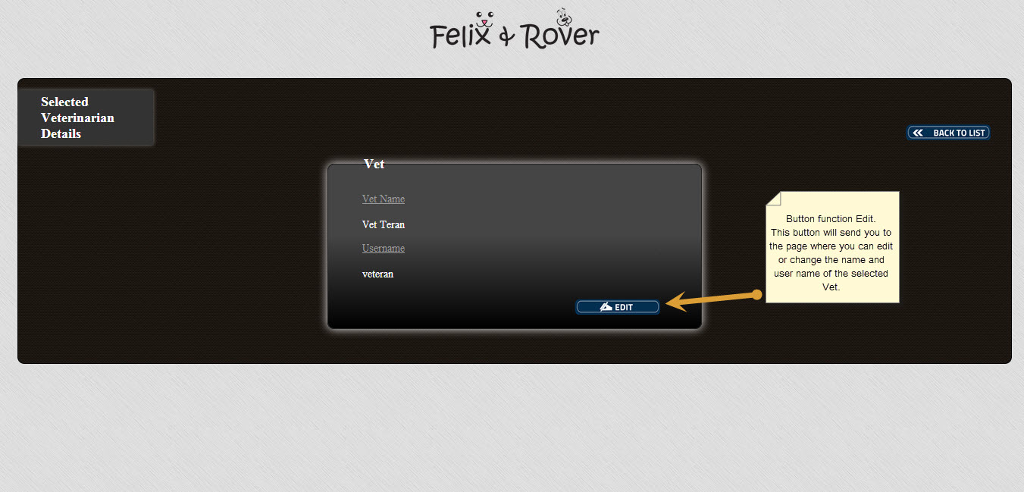

**‘Update Selected Veterinarians’ Page** – This page is where you can update vet details if you wish to make changes to its vet name, user name, and password.

